**Bytewise Fellowship**

**Muhammad Ahtasham**

**1.Installation:**

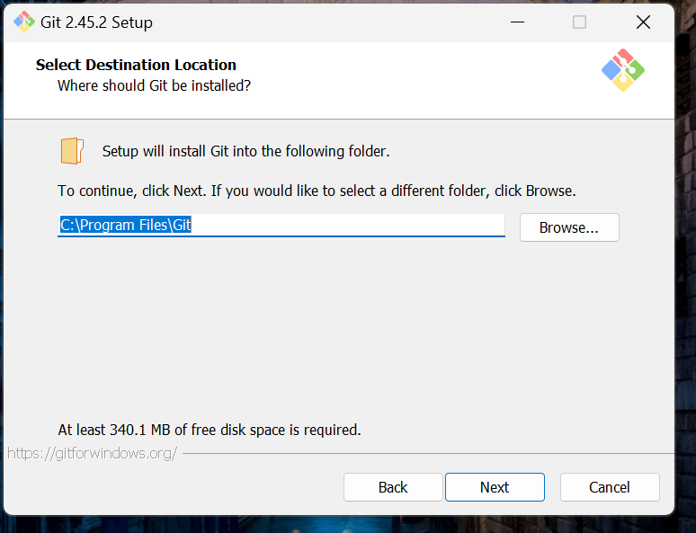

**2.Git Version:**

**3. Git Clone:**

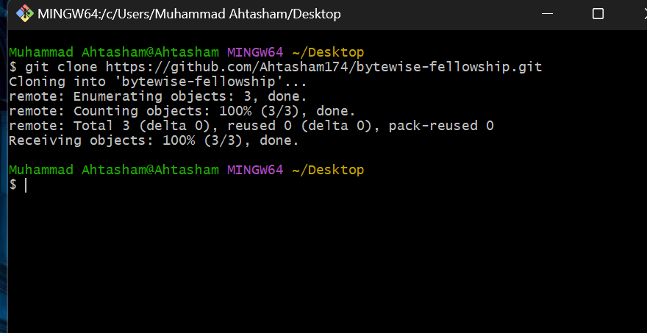

**4.Git Init:**

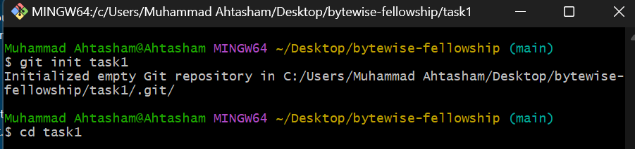

**5.Echo:**



**6.Git Commit:**

